Inscribed Circle
# Source: AI Source: Provided by: [Data Path: Persons Table -> ID Column: 1, Name_En Column: Motasem Essam] -> From: [ChatGPT] on [7/25/2026]
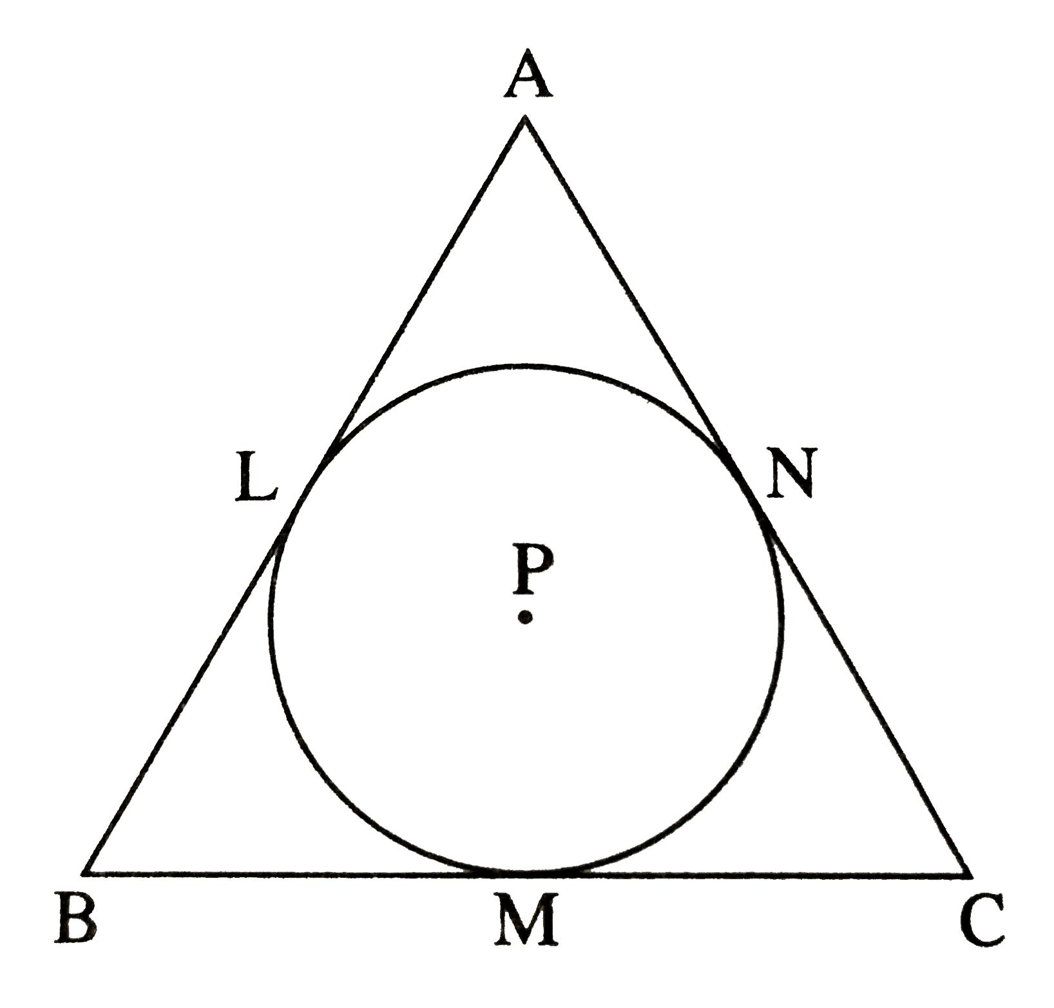
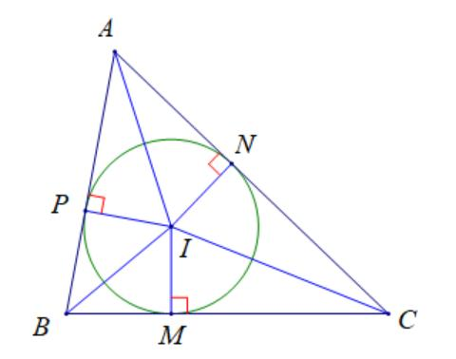
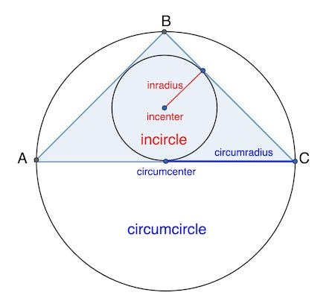
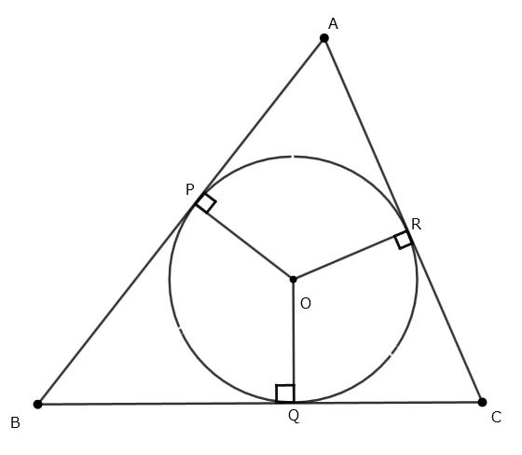
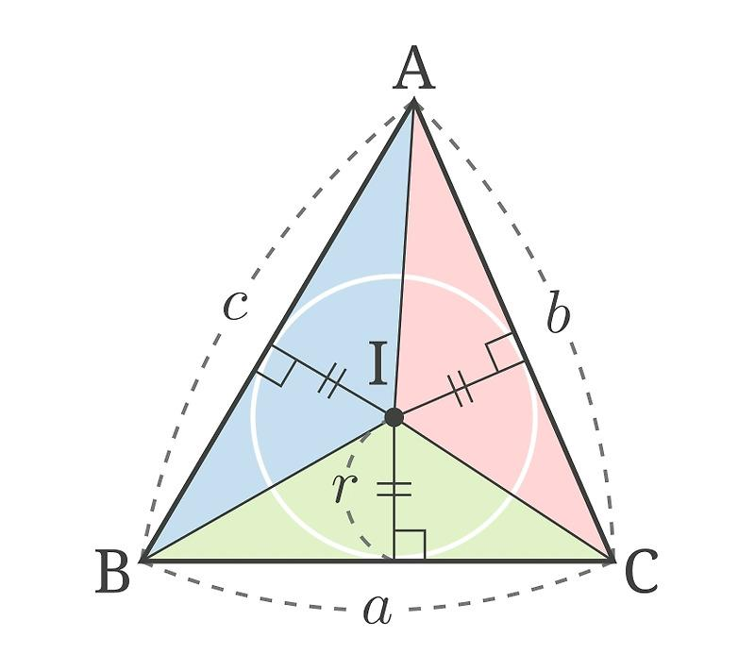

Definition
# Source: AI Source: Provided by: [Data Path: Persons Table -> ID Column: 1, Name_En Column: Motasem Essam] -> From: [ChatGPT] on [7/25/2026]
An Inscribed Circle is a circle that lies inside a polygon or other geometric figure and is tangent to each of its sides or boundaries.
In a triangle, an inscribed circle is specifically called an Incircle.
The center of the inscribed circle is called the Incenter.
For a triangle $ABC$, the incircle touches all three sides:
$$\overset{‾}{AB}, \overset{‾}{BC}, \overset{‾}{CA}$$
at exactly one point on each side.

Fundamental Concept
# Source: AI Source: Provided by: [Data Path: Persons Table -> ID Column: 1, Name_En Column: Motasem Essam] -> From: [ChatGPT] on [7/25/2026]
For a triangle:
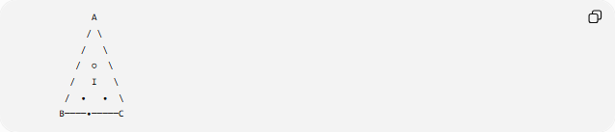
A
/ \
/ \
/ ○ \
/ I \
/ • • \
B────•─────C
Where:
- $I$= incenter
- ○ = inscribed circle
- The three points of contact lie on the three sides.
- Each radius from $I$to a point of contact is perpendicular to that side.
Thus:
$$\boxed{\text{Inscribed Circle}=\text{Circle tangent to all sides of the figure}}$$

Main Parts
# Source: AI Source: Provided by: [Data Path: Persons Table -> ID Column: 1, Name_En Column: Motasem Essam] -> From: [ChatGPT] on [7/25/2026]
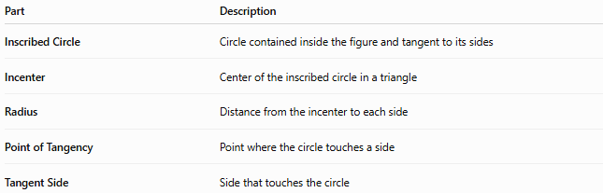
Part | Description
Inscribed Circle | Circle contained inside the figure and tangent to its sides
Incenter | Center of the inscribed circle in a triangle
Radius | Distance from the incenter to each side
Point of Tangency | Point where the circle touches a side
Tangent Side | Side that touches the circle

Incircle of a Triangle
# Source: AI Source: Provided by: [Data Path: Persons Table -> ID Column: 1, Name_En Column: Motasem Essam] -> From: [ChatGPT] on [7/25/2026]
Every non-degenerate triangle has exactly one incircle.
The incircle is tangent to all three sides of the triangle.
Its center is the intersection of the three internal angle bisectors.
$$\boxed{I=\text{intersection of the three angle bisectors}}$$
The incenter is therefore equidistant from all three sides.

Radius of an Inscribed Circle
# Source: AI Source: Provided by: [Data Path: Persons Table -> ID Column: 1, Name_En Column: Motasem Essam] -> From: [ChatGPT] on [7/25/2026]
The radius of an incircle is called the inradius, usually denoted by $r$.
Because the circle is tangent to every side:
$$\boxed{d\left(I , AB\right)=d\left(I , BC\right)=d\left(I , CA\right)=r}$$
where $d\left(I , AB\right)$represents the perpendicular distance from the incenter to side $AB$.

Perpendicular Radius Property
# Source: AI Source: Provided by: [Data Path: Persons Table -> ID Column: 1, Name_En Column: Motasem Essam] -> From: [ChatGPT] on [7/25/2026]
A radius drawn from the center to a point of tangency is perpendicular to the tangent side.
For example, if the circle touches $AB$at $D$:
$$\boxed{ID⊥AB}$$
and:
$$\boxed{ID=r}$$
The same relationship applies to all three sides.

Incenter and Angle Bisectors
# Source: AI Source: Provided by: [Data Path: Persons Table -> ID Column: 1, Name_En Column: Motasem Essam] -> From: [ChatGPT] on [7/25/2026]
The incenter lies on all three internal angle bisectors.
For triangle $ABC$:
$$\boxed{I=\text{intersection of the internal angle bisectors}}$$
Therefore:
$$∠BAI=∠IAC \\ ∠ABI=∠IBC \\ ∠ACI=∠ICB$$

Inradius Formula
# Source: AI Source: Provided by: [Data Path: Persons Table -> ID Column: 1, Name_En Column: Motasem Essam] -> From: [ChatGPT] on [7/25/2026]
For a triangle with area $A$and semiperimeter $s$:
$$\boxed{A=rs}$$
Therefore:
$$\boxed{r=\frac{A}{s}}$$
where:
$$\boxed{s=\frac{a+b+c}{2}}$$
Thus:
$$\boxed{r=\frac{2A}{a+b+c}}$$

Example
# Source: AI Source: Provided by: [Data Path: Persons Table -> ID Column: 1, Name_En Column: Motasem Essam] -> From: [ChatGPT] on [7/25/2026]
Suppose a triangle has sides:
$$a=5, b=6, c=7$$
Its semiperimeter is:
$$s=\frac{5+6+7}{2}=9$$
The area is:
$$A=6\sqrt{6}$$
Therefore:
$$r=\frac{A}{s} \\ r=\frac{6\sqrt{6}}{9} \\ \boxed{r=\frac{2\sqrt{6}}{3}}$$
approximately:
$$\boxed{r≈1.63}$$

Area Decomposition
# Source: AI Source: Provided by: [Data Path: Persons Table -> ID Column: 1, Name_En Column: Motasem Essam] -> From: [ChatGPT] on [7/25/2026]
The incircle's center $I$divides the triangle into three smaller triangles:
$$△IAB, △IBC, △ICA$$
Because the perpendicular distance from $I$to every side is $r$:
$$A=\frac{1}{2}ar+\frac{1}{2}br+\frac{1}{2}cr$$
Therefore:
$$A=\frac{1}{2}\left(a+b+c\right)r$$
Since:
$$s=\frac{a+b+c}{2}$$
we obtain:
$$\boxed{A=rs}$$

Tangent Segments
# Source: AI Source: Provided by: [Data Path: Persons Table -> ID Column: 1, Name_En Column: Motasem Essam] -> From: [ChatGPT] on [7/25/2026]
When two tangent segments are drawn from the same external point to a circle, their lengths are equal.
For a triangle's incircle, if the points of tangency divide the sides, equal tangent lengths arise from each vertex.
For example:
$$\boxed{AF=AE}$$
if $AE$and $AF$are tangent segments from vertex $A$.
Similarly:
$$\boxed{BF=BD}$$
and:
$$\boxed{CE=CD}$$
This property is useful when determining unknown side portions.

Inscribed Circle in a Polygon
# Source: AI Source: Provided by: [Data Path: Persons Table -> ID Column: 1, Name_En Column: Motasem Essam] -> From: [ChatGPT] on [7/25/2026]
The concept can be extended beyond triangles.
A polygon that has a circle tangent to all of its sides is called a tangential polygon or circumscribed polygon.
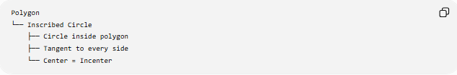
Polygon
└── Inscribed Circle
├── Circle inside polygon
├── Tangent to every side
└── Center = Incenter
Not every polygon necessarily has an inscribed circle.

Regular Polygon
# Source: AI Source: Provided by: [Data Path: Persons Table -> ID Column: 1, Name_En Column: Motasem Essam] -> From: [ChatGPT] on [7/25/2026]
Every regular polygon has an inscribed circle.
Its center coincides with the polygon's center.
The inradius is also called the apothem of the regular polygon.
Thus:
$$\boxed{r=a_{p}}$$
where $a_{p}$is the apothem.
The polygon's area can therefore be calculated using:
$$\boxed{A=\frac{1}{2}Pr}$$
where:
- $P$= perimeter
- $r$= inradius/apothem

Inscribed Circle vs Circumscribed Circle
# Source: AI Source: Provided by: [Data Path: Persons Table -> ID Column: 1, Name_En Column: Motasem Essam] -> From: [ChatGPT] on [7/25/2026]
These terms describe opposite relationships.
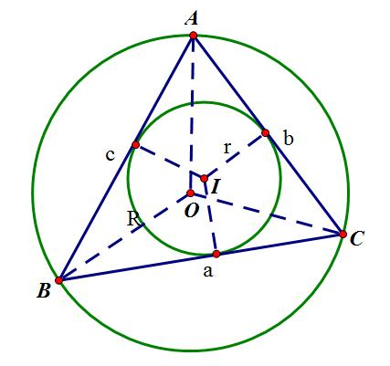
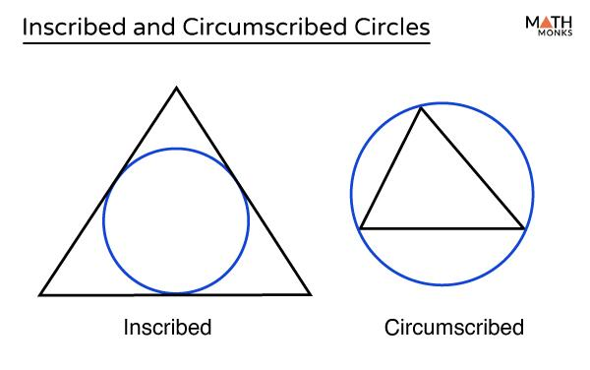
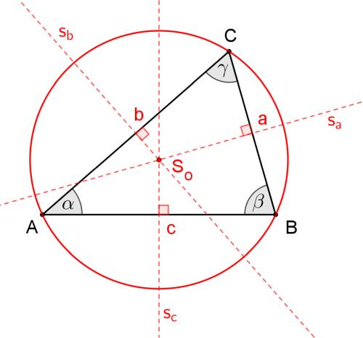
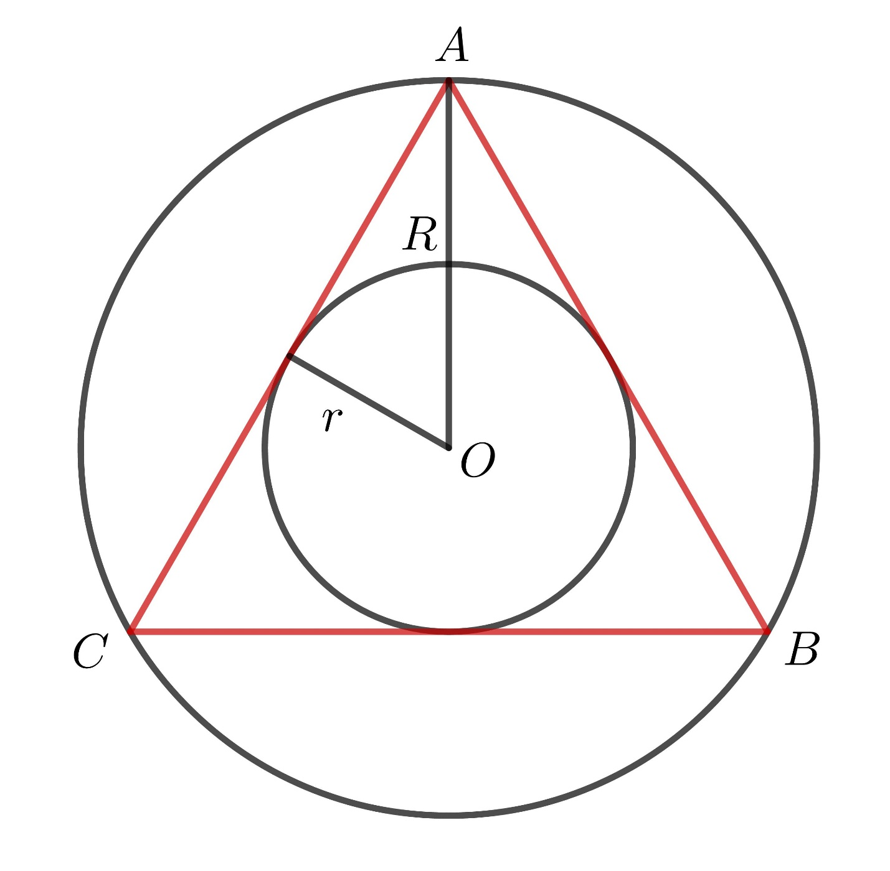
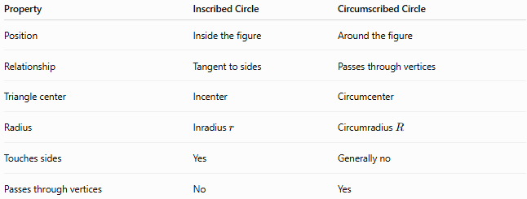
Property | Inscribed Circle | Circumscribed Circle
Position | Inside the figure | Around the figure
Relationship | Tangent to sides | Passes through vertices
Triangle center | Incenter | Circumcenter
Radius | Inradius $r$ | Circumradius $R$
Touches sides | Yes | Generally no
Passes through vertices | No | Yes
For a triangle:
$$\boxed{\text{Incircle}↔\text{Incenter}} \\ \boxed{\text{Circumcircle}↔\text{Circumcenter}}$$

Inscribed Circle vs Circle Inscribed in a Triangle
# Source: AI Source: Provided by: [Data Path: Persons Table -> ID Column: 1, Name_En Column: Motasem Essam] -> From: [ChatGPT] on [7/25/2026]
In triangle geometry, these expressions refer to the same fundamental object:
- Inscribed Circle
- Incircle
- Circle inscribed in a triangle
The term incircle is the standard specialized term for a triangle.

Special Cases
# Source: AI Source: Provided by: [Data Path: Persons Table -> ID Column: 1, Name_En Column: Motasem Essam] -> From: [ChatGPT] on [7/25/2026]
Equilateral Triangle
For an equilateral triangle with side length $a$:
$$\boxed{r=\frac{\sqrt{3}}{6}a}$$
The incenter, centroid, circumcenter, and orthocenter all coincide.
Right Triangle
For a right triangle with legs $a,b$and hypotenuse $c$:
$$\boxed{r=\frac{a+b-c}{2}}$$
General Triangle
For any triangle:
$$\boxed{r=\frac{A}{s}}$$

Classification
# Source: AI Source: Provided by: [Data Path: Persons Table -> ID Column: 1, Name_En Column: Motasem Essam] -> From: [ChatGPT] on [7/25/2026]
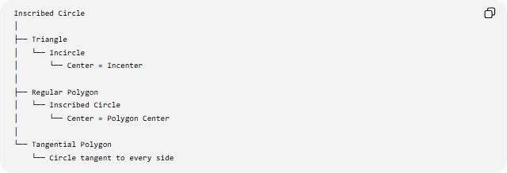
Inscribed Circle
│
├── Triangle
│ └── Incircle
│ └── Center = Incenter
│
├── Regular Polygon
│ └── Inscribed Circle
│ └── Center = Polygon Center
│
└── Tangential Polygon
└── Circle tangent to every side

Important Relationships
# Source: AI Source: Provided by: [Data Path: Persons Table -> ID Column: 1, Name_En Column: Motasem Essam] -> From: [ChatGPT] on [7/25/2026]
Incenter
$$\boxed{I=\text{intersection of internal angle bisectors}}$$
Inradius
$$\boxed{r=\frac{A}{s}}$$
Triangle Area
$$\boxed{A=rs}$$
Perpendicularity
$$\boxed{\text{Radius to point of tangency}⊥\text{tangent side}}$$
Tangent Lengths
Tangents from the same external point have equal lengths.

Key Points
# Source: AI Source: Provided by: [Data Path: Persons Table -> ID Column: 1, Name_En Column: Motasem Essam] -> From: [ChatGPT] on [7/25/2026]
- An Inscribed Circle lies inside a figure and is tangent to its sides or boundaries.
- In a triangle, it is called an Incircle.
- The center of a triangle's incircle is the Incenter.
- The incenter is the intersection of the three internal angle bisectors.
- The distance from the incenter to every side is the inradius.
- A radius to a point of tangency is perpendicular to the corresponding side.
- For a triangle:
$$\boxed{A=rs}$$
- Every regular polygon has an inscribed circle.
- A polygon that admits a circle tangent to all its sides is called a tangential polygon.

Conclusion
# Source: AI Source: Provided by: [Data Path: Persons Table -> ID Column: 1, Name_En Column: Motasem Essam] -> From: [ChatGPT] on [7/25/2026]
An Inscribed Circle is a circle contained within a geometric figure and tangent to its sides or boundaries. In a triangle, the inscribed circle is the incircle, its center is the incenter, and its radius is the inradius. The concept connects tangency, angle bisectors, triangle area, polygon geometry, and circle geometry.

